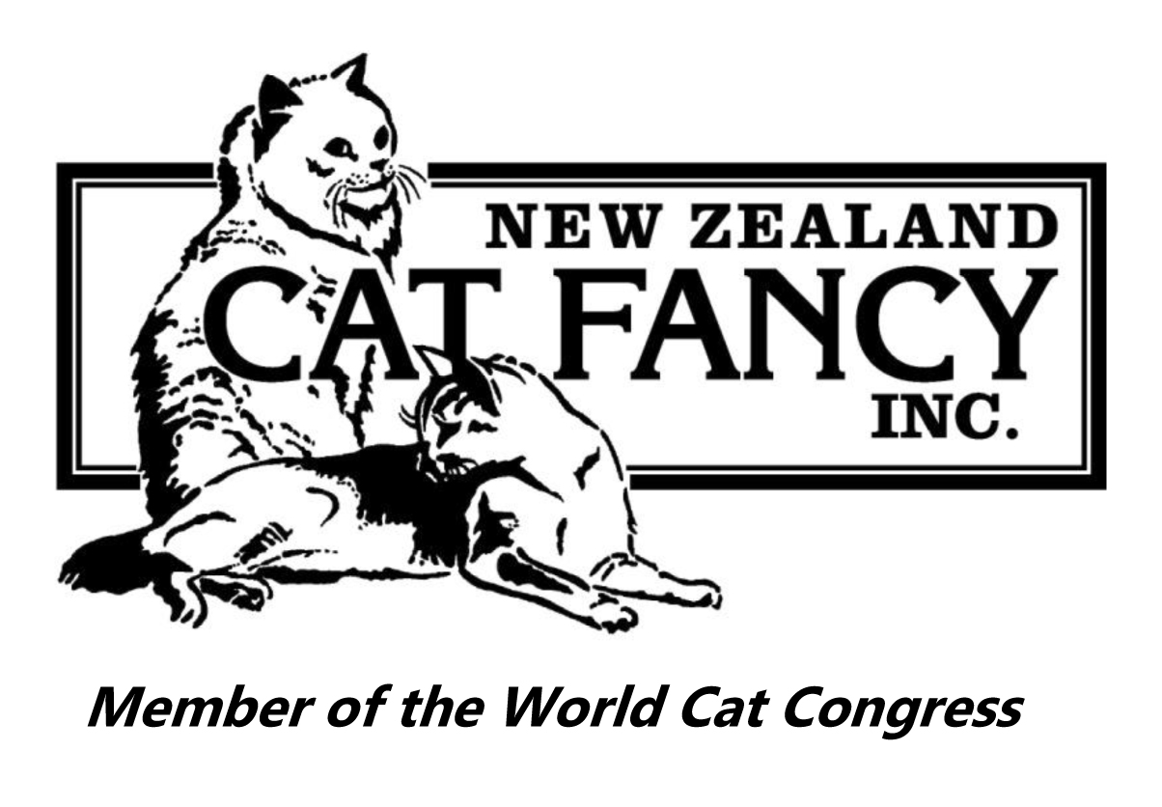
NEW ZEALAND CAT FANCY INC.
Cage No.

Reclassification at Shows
Club: Show Date:
Concern has been raised that your kitten or non-titled cat (details below) has been registered incorrectly.
Breed:
Sex:
Name:
Registration Number:
Owner:
Under the NZCF’s Registration Rules your kitten or non-titled cat can be reclassified on show day with the agreement of three judges.
We confirm that we have inspected this exhibit and have found it to be incorrectly registered as:
Currently registered colour:
(including tabby pattern, if applicable)
The correct registration for this exhibit is:
Corrected colour:
(including tabby pattern, if applicable)

 | Judge (printed name) | Judge (signature)
1
2
3
Reclassification is acknowledged:
Note: There is a charge for colour changes in NZCF records for adult cats. (Refer Schedule of Fees.)
(signature)
Show Secretary
Owner:
Copies of this form to be retained by:
- Show Secretary
- Owner
Copy to be sent to:
- LH / SH / PR Registrar (as applicable)

