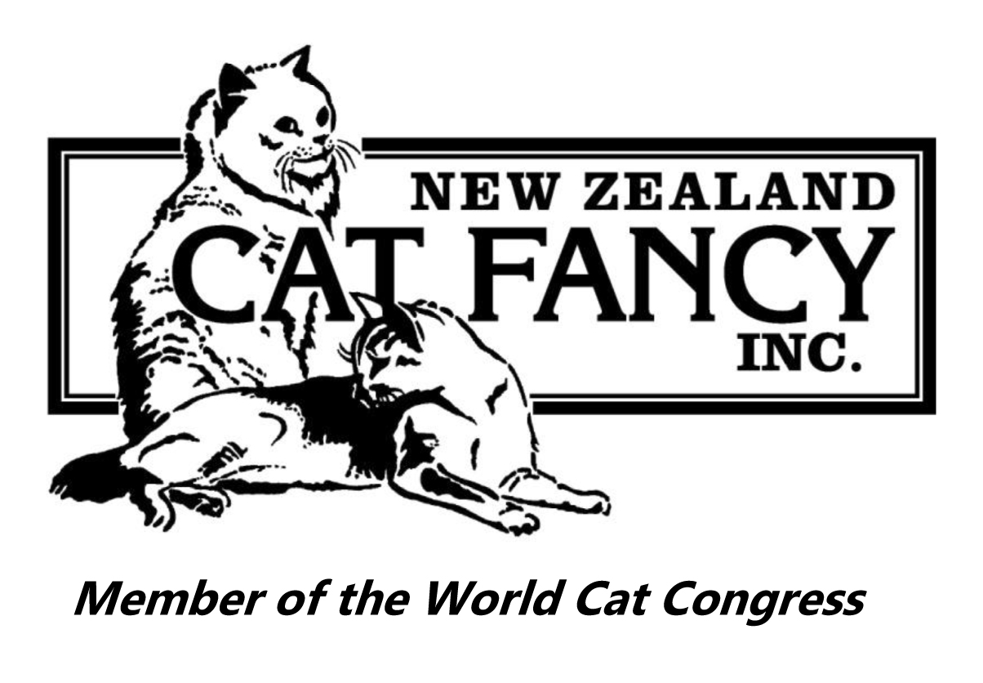
NEW ZEALAND CAT FANCY INC.
Honours Medallion Order Form
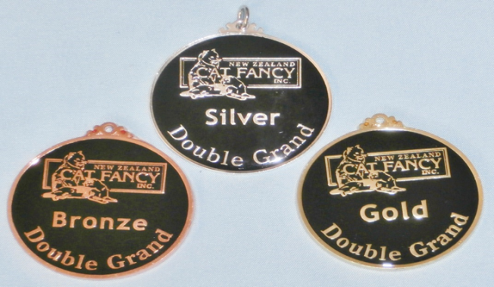
If your cat is now a Bronze, Silver, Gold, Sapphire, Ruby, or Emerald Double Grand Champion or Bronze, Silver, Gold, Sapphire, Ruby, or Emerald Double Grand Premier we have medallions available for purchase as an additional memento.
Each medallion is 5 cm (2 ins) and circular in shape.
Name of Cat:
Medallion(s) Required: | Bronze / Silver / Gold / Sapphire / Ruby / Emerald
Owner’s Name and
Postal Address:
Post to: Sheree Russell Or email to: Honours@nzcatfancy.org.nz
NZ Cat Fancy Honours Registrar
102 Whibley Road
RD2
Otorohanga 3972
Cost: $20.00 per medallion.
Payment Details
- Please make cheques payable to NZ Cat Fancy Inc.
- For payment by direct credit please deposit into the following account and leave a good identifying reference so it is apparent who the payment is from and what it is for.
New Zealand Cat Fancy Inc
15-3945-0265474-00
TSB Bank Ltd, Waitara
- For payment by credit card, please fill in the details below.
Note: We cannot accept American Express or Diners Club credit cards.
Type of Credit card (e.g. Visa, Mastercard, etc): | Name of card holder on card:
Card Number: | Expiry date:

