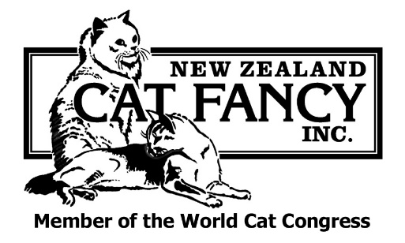
Executive Council Secretary
Sharon José
34 Second Ave
RD 3
Te Aroha 3393
Ph: 07 884 9358
Email: secretary@nzcf.com
INFORMATION SHEET FOR NEW BREEDERS

REQUIREMENTS FOR PREFIX APPLICATION

- The points listed below are designed as a guide for new breeders and to be used in conjunction with the NZCF Rules & Bylaws issued to all prefix applicants upon payment of the application fee.

- Application must be made on the official prefix application form available from the Secretary or able to be downloaded at the NZCF website which can be found at www.nzcf.com The form must be fully completed and signed by all parties.

- The prefix application must be in the same name or names as the ownership of the breeding queen. It is ESSENTIAL that the queen's ownership has been correctly transferred PRIOR to the birth of a litter as the breeder is the owner of the queen at the time of the birth of the kittens. Therefore, this is the person (or persons) who requires a prefix to register the litter. People wishing to breed under a jointly owned prefix should ensure that all breeding queens owned by them are TRANSFERRED TO THE OWNERSHIP OF ALL PARTNERS OF THE PROPOSED PREFIX. Kittens cannot be registered from a jointly owned queen under a prefix which is in single ownership and vice versa.

- Applicants must be a financial member of a NZCF affiliated club and the club secretary’s signature must appear on the form indicating support from the club. They must also be full members of the NZCF itself. The NZCF membership application form can also be downloaded from the website or is available from the Secretary.

- All prefix applicants must have their prefix application forms signed and dated by three current NZCF registered prefix holders who must also provide the name of their prefix on the form. Prefix holders selling breeding stock are expected to provide this service and committee members of the club the applicant is a member of.

- It is essential to be original when selecting choices. No NZ place names, names of countries, well known trade names, recognised titles or colours or names of famous persons are acceptable. Choices must be one word only. Choices will not be accepted which are identical or bear a close resemblance to prefixes already registered in NZ or well-known overseas prefixes. The length of prefixes is restricted to not more than 14 letters. While all choices are dealt with in the order of preference, it is assumed applicants are happy with all choices upon the application form, i.e. if you wouldn't like a choice as a prefix, then don't put it on the application form as you may well end up with it as your prefix.

- The prefix application fee is $85.00. Copies of the NZCF Registration Rules and Show Bylaws booklets will be provided at the time of application. The application fee is payable at the time the prefix application is lodged. Please make all cheques payable to NZ Cat Fancy Inc. Payment can also be made by Direct Debit or Credit Card.

- There can only be a maximum of 3 persons at any one time as joint owners in any one prefix.

- An application for a prefix should be lodged prior to taking possession of a breeding queen. It is desirable prefix application is not left until the last minute. At a minimum it will take at least 4 weeks (usually 6 - 8) before a prefix can be confirmed.

- Prefix lists are circulated regularly to clubs and officials. If no objection is received from any club after 28 days from circulation you will receive a prefix certificate which will show that your prefix choice is now a registered prefix. You can then commence to use the prefix.

- If an objection is lodged, you will be notified in writing. You will also be advised as to the proposed course of action. If another choice has to be substituted, then the same 28 day wait in case of objection will apply.

- Cats bred under a jointly owned prefix must show the names of all the owners on their registrations, transfers, show entries, pedigrees, etc.

- There is no restriction as to what variety of cat can be bred under a prefix. An initial S/H designation does not preclude L/H breeding in the future and vice versa. There is no necessity for official permission or any alteration to the prefix to change breeds. A L/H or S/H designation at the time of application for a prefix is just intended as a guide for the other Registrars.

- Please state the name of the breed you are intending to breed, so a general type standard for the breed can be supplied to you.

- It is strongly recommended that breeders wishing to purchase a cat or kitten not already registered with the NZCF please check with our registrars that its pedigree is acceptable to the NZCF before making a commitment to purchase.

- Please do not feel afraid to approach any official of the Fancy if you have a problem as our job is to assist breeders. We do expect you will have read the relevant rules prior to your approach, so that you are fully conversant with them.

