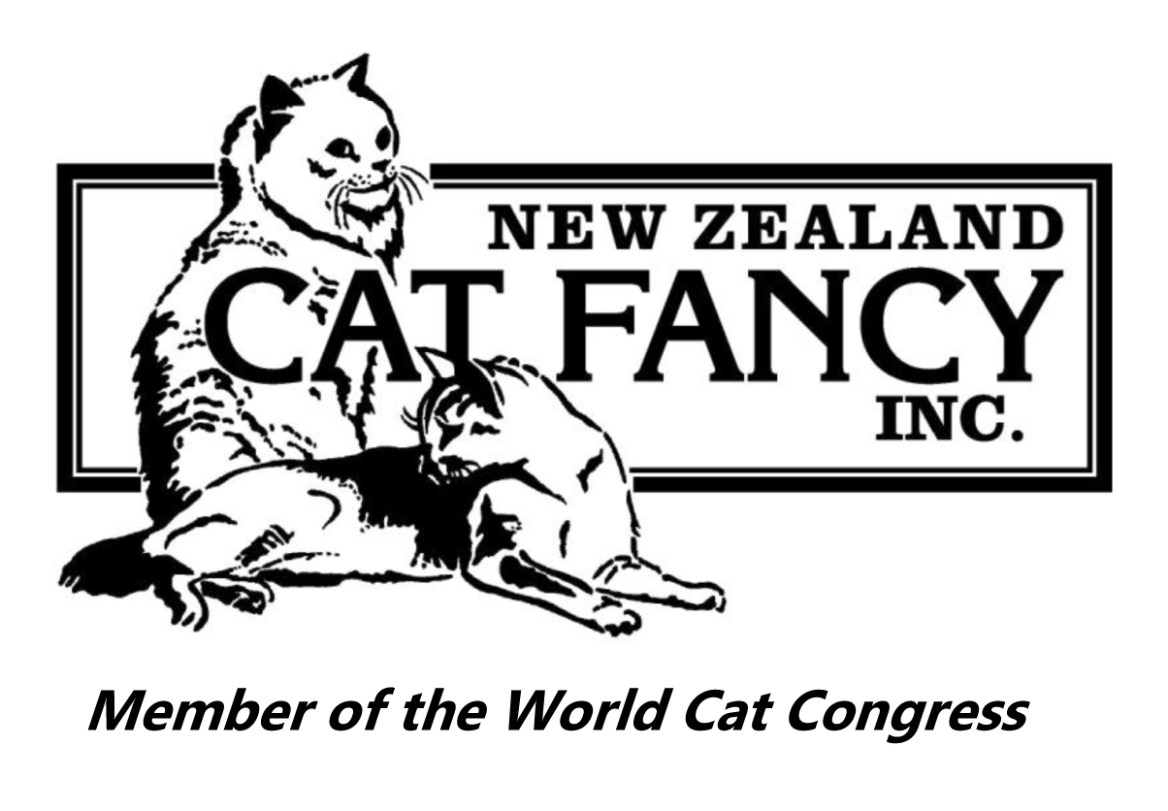
NEW ZEALAND CAT FANCY INC.

Cage No.
Unable to be Judged / Handled Certificate
Club: Show Date:
In order to reduce the risk of harm to handlers and judges, and distress to your cat, your cat has been assessed as unable to be judged (UTJ) or unable to be handled (UTH).
It is appreciated that this will be a disappointment to you but the show organisers hope that you understand that the safety of people and welfare of cats is our primary concern.
You are hereby advised that your (breed, type) (sex) cat, known as (name), owned by (owner name) of (owner address) was assessed as unable to be judged or handled as follows:
❑ Unable to be Judged
A cat that is unable to be judged due to being nervous or angry, and demonstrates its disapproval at being exhibited by noise and a menacing attitude, without attacking or savaging any person.
I consider that this cat is unable to be judged according to the definition of UTJ.
(judge's signature) (ring) (date)
Other judges shall be advised when an exhibit is declared unable to be judged (UTJ) at a show.

❑ Unable to be Handled
A cat that is unable to be handled due to being vicious or savage and attacks or injures any person who is authorised to handle the cat during a show.
I consider that this cat is unable to be handled according to the definition of UTH.
(judge's signature) (ring) (date)
Any exhibit declared unable to be handled (UTH) at a show shall be automatically withdrawn from any subsequent judgings at that show.
Any exhibit unable to be judged (UTJ) at three shows during one show season shall be disqualified for the remainder of that season only.
An exhibit declared unable to be handled (UTH) at two shows shall be permanently debarred from showing.
Copies of this certificate to:
Shows Portfolio Manager, Exhibitor, and Club holding show for their files

