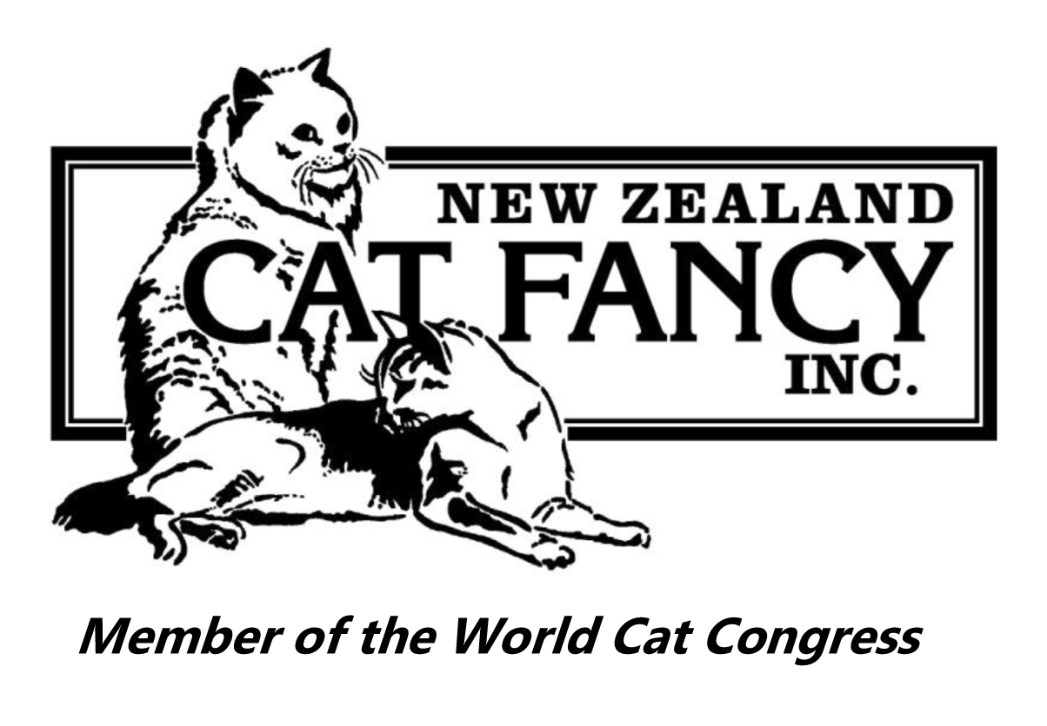
NEW ZEALAND CAT FANCY INC.
Permission for Early Departure from a Show
In accordance with Show Bylaws, para 10.8:
Removal of an exhibit before the show has been officially closed without the prior permission of the Show Manager or Show Secretary will result in the loss of all club awards and NZCF annual awards points and any title points.
Planned early departures
Permission should be sought as soon as possible, and a minimum of 24 hours before the start of the show, using this form.
Emergency early departures
Require the permission of the Show Manager or Show Secretary and that should be recorded on this form.

Club or Name of Show:
Date of Show:
Exhibitor Name:

Approved:
Show Manager / Show Secretary Date

